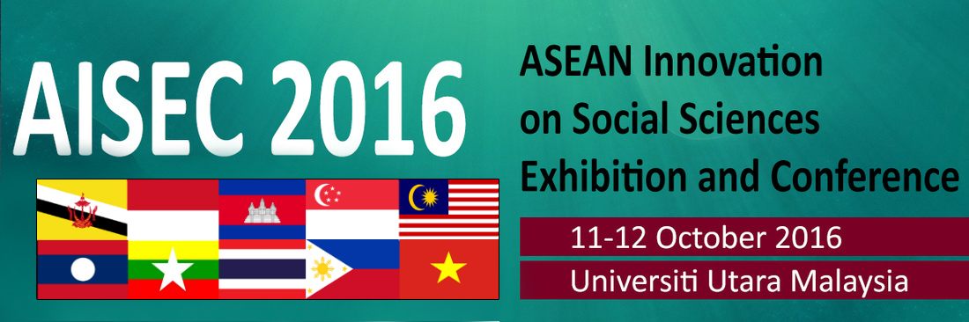
REGISTRATION FORM

SECTION A: PERSONAL DETAILS

Name: | ________________________________________________________________________
 | (First Name) |  |  | (Middle name) |  | (Last Name)
Gender | Male / Female
Organization/ University |  |  | ______________________________________________________
Address | _______________________________________________________________________
 | _______________________________________________________________________
Country | ___________________________ |  |  | Postcode : | ________________________
Phone: | ___________________________ |  |  | _____________________________________
 | (Area Code) |  |  | (Phone Number)
Email | _______________________________________________________________________
Special Requirements: |  | _____________________________________________________________
 |  | (Food restriction, etc.)

SECTION B: FEES (Please tick appropriate box):

International Participant |  | USD 100 | Malaysian Participant |  | RM 300

SECTION C: DECLARATION

I hereby declare that the information provided in this application is true and complete in every detail. I authorize Universiti Utara Malaysia to handle and use my personal data/information for the purposes of the program.

Signature: | Date:
________________________________ | __________________
Payment Method
1. By Credit Card (Online)
- Browse UUM e-com (http://e-com.uum.edu.my/bend/paymode.jsp)
- Follow all required steps as instructed. The payment is (USD100 or RM400).
- Note : for 'payment for' choose ‘other payment’
- Note : for 'description' : key in ‘AISEC’16 (Presenter/Participation)’
- Please print and keep the notification of payment made as proof of payment. Scan and email the proof of payment as soon as possible or before 19 September 2016 to the secretariat (aisecuum16@gmail.com). You also need to bring the original payment slip during the registration. You are required to show the proof of payment to the secretariat on the registration day of the conference/ workshop/ colloquium. Failure to do so will result in your name being not listed as presenter/ participants.
2. Telegraphic Transfer / Bank Transfer
Transfer should be made to the following account:
Account Name: UNIVERSITI UTARA MALAYSIA
Account No.: 02093010000010
Bank Name: BANK ISLAM MALAYSIA BERHAD
SWIFT CODE: BIMBMYKL
Please include in your payment:
- The total registration fees; wire transfer fees are the responsibility of the registrant (Registrants are required to bear the processing fee charged by their own bank and a third party agent (if any).
- Your organization's name as it appears in the reference section of your transfer
- Please write a remark "REGISTRATION FEE FOR AISEC 2016"
Please forward a scanned copy of the telegraphic transfer receipt to AISEC’16 Secretariat (aisecuum16@gmail.com with cc to mazida@uum.edu.my) or by fax to +604 9285310 for us to verify the transaction. Please kindly write down the participant's name, date and time of the transfer and country and city of origin.
Kindly note that NO International Cheque will be accepted

Kindly send or e-mail us the registration form and proof of your payment (for the purpose of verification) before 19 September 2016.

For further enquiries, please do not hesitate to contact:
Dr. Mazida Ahmad : +6019-576 1252
Dr. Bahtiar Mohamad : +604-9285020

E-mail: aisecuum16@gmail.com
Website: http://aisecuum16.weebly.com

